The Electric Vehicle Buyers Guide

Thesis Paper for I-492 Project

by

Jake Cook

Advisor
Dr. Sridhar Ramachandran

Table of Contents
I. Abstract 3
II. Introduction 3
III. Literature Review 4
IV. Methods 4
V. Results 4
VI. Discussion 4
VII. Conclusion 4
VIII. Future Directions 4
List of References 5
Link to the References 5

I. Abstract
This study investigates the carbon dioxide (CO₂) emissions of electric vehicles (EVs) across the United States, accounting for regional differences in electricity generation. While EVs produce no tailpipe emissions, their overall environmental benefit depends heavily on how electricity is generated in each state. Using 2022 data from the U.S. Environmental Protection Agency, this research calculates grams of CO₂ per mile for EVs and compares these values with those of high-efficiency internal combustion engine (ICE) and hybrid vehicles. Results reveal that in all 50 states, EVs emitted more CO₂ per mile than their ICE counterparts, with the gap widening significantly in fossil fuel-dependent regions. An interactive dashboard was developed using R and Shiny to visualize these differences by state. Findings challenge the common assumption that EVs are always more environmentally friendly and highlight the need for state-specific clean energy policies. This research underscores the importance of decarbonizing the power grid to maximize the potential benefits of EV adoption and suggests that policy incentives should be geographically targeted. The study contributes a practical, real-time framework for evaluating vehicle emissions, offering consumers and policymakers a clearer understanding of EV sustainability in context.

II. Introduction
The transition to electric vehicles (EVs) has been widely promoted as a key strategy for reducing greenhouse gas emissions in the transportation sector. As the adoption of EVs accelerate, it is important to critically asses whether these vehicles consistently deliver an environmental benefit across the United States. While EVs produce no physical tailpipe emissions, the electricity required to charge them must be generated, which produces a carbon dioxide emission. The environmental impact of EVs is therefore closely and directly tied to the regional power grid mix and efficiency, which varies significantly by state.
This research investigates the carbon dioxide emissions associated with EV use across the United States, with the aim of evaluating how regional differences in electricity generation affect the overall emissions performance of EVs compared to fuel-efficient internal combustion engine (ICE) vehicles and hybrids.
The central hypothesis of this study is that while EVs offer less routine maintenance and a greater operating convenience than traditional ICE vehicles, depending on what state you live in their advantage in emissions diminishes-or even reverses- in states with high-carbon electricity generation. In such states, the environmental benefits of EVs may be grossly overstated, particularly when compared to modern fuel-efficient gasoline or hybrid vehicles.
This research holds significant implications for U.S. policy makers. Current incentive structures overwhelmingly favor EV adoptions, yet they overlook the critical and dependent role of the power grid in determining how well these vehicles solve the problem they have been deployed to solve. By analyzing EV performance in the context of state-level electricity emissions, this study highlights the need for energy infrastructure improvements alongside vehicle electrification efforts to ensure their carbon reducing effects. A more region-specific approach to clean transportation policy may yield more meaningful progress in reducing national CO₂ emissions.

III. Literature Review
Electric vehicles (EVs) are frequently promoted as a cleaner alternative to internal combustion engine (ICE) vehicles, yet a growing body of literature challenges the assumption that EVs are inherently sustainable. This review synthesizes findings from over a dozen studies addressing electricity generation emissions, vehicle life cycle analysis, charging behavior, and policy effectiveness. Collectively, these works highlight the importance of regional power grid composition, temperature effects, and charging behavior in determining the true carbon footprint of EVs. While many studies support the environmental benefits of EVs in regions powered by low-carbon electricity, others show that in coal-heavy states or under certain charging conditions, EVs can emit as much—or more—CO₂ per mile as efficient hybrids like the Toyota Prius.
A central theme across studies is the regional variability of power plant emissions and its impact on EV sustainability. Ghosh et al. (2023) and Qin et al. (2022) show that CO₂ emissions from electricity generation can vary significantly depending on a state or country's energy mix, with coal-heavy grids producing over five times the emissions of cleaner, renewable-driven regions. Tamayao et al. (2015) and Singh et al. (2024) extend this idea by using life cycle assessments (LCAs) to compare EVs and hybrids across different U.S. regions. Both find that hybrids can outperform EVs in areas with high electricity carbon intensity. Notably, Singh introduces the concept of a “critical emissions factor” (CEF), a threshold above which an EV's carbon footprint exceeds that of a hybrid.
In addition to grid composition, charging behavior significantly affects emissions outcomes. McLaren et al. (2016) and Isaac et al. (2024) demonstrate that time-of-day charging and the use of marginal emissions factors (MEFs) rather than average values can drastically change CO₂ calculations. For instance, charging at night in fossil-fuel-dominant regions can raise EV emissions compared to daytime charging when renewable energy is more prevalent. Environmental conditions such as climate and seasonal variability are also shown to impact EV emissions. Ansari et al. (2024) finds that cold temperatures increase energy demand and CO₂ output from plug-in hybrids by up to 290%. These results align with Peters et al. (2020), who show that health and climate benefits from EVs depend on both grid emissions and local air quality conditions. On the policy front, Jenn et al. (2018) and Clinton & Steinberg (2019) analyze the effectiveness of financial incentives, concluding that rebates and tax credits significantly drive EV adoption but often favor wealthier consumers. Meanwhile, Kim (2023) critiques recent U.S. policy under the Inflation Reduction Act (IRA) for its protectionist stance, which may hinder international cooperation despite promoting domestic manufacturing.
This literature underscores a critical insight for the present study: EVs are not inherently low-carbon; their emissions are a function of location, grid conditions, and user behavior. The lack of a standardized per-mile CO₂ metric that integrates emissions from power plants creates confusion for both consumers and policymakers. While prior work has established that regional factors matter, few studies offer a practical, real-time method for comparing EV and ICE vehicle emissions on a consistent basis.
By developing a transparent framework to calculate grams of CO₂ per mile for EVs based on regional electricity generation emissions, this research directly addresses a gap in existing literature. In doing so, it aims to equip consumers with a more accurate sustainability metric and inform policy recommendations that consider regional grid conditions rather than assuming uniform EV benefits nationwide.

IV. Methods
This study utilized three datasets obtained from the United States Environmental Protection Agency (EPA). The first datasets included carbon dioxide (CO₂) emissions from powerplants, measured in millions of tons at the state level from 1970 to 2022. The second dataset contained vehicle specifications, including make model, fuel type and various other metrics, for vehicles manufactured between 1984 and 2025. The third dataset provided information on kilowatt-hour(kWh) sales, generation, and capacity at the state level for the year 2022. This energy generation dataset was essential to the research, as it enabled a comparison of how much electricity each state generated versus how much CO₂ was emitted-allowing for the evaluation of each state’s energy production efficiency.
To ensure alignment between vehicle and energy data, only vehicles from the 2022 model year were included in the analysis. Within the dataset, the combined efficient rating (miles per gallon or miles per kilowatt-hour) was selected over city or highway-specific values to provide a more generalizable emissions estimate. The vehicle dataset required substantial preprocessing due to inconsistent formatting and cryptic variable labeling. After rigorous cleaning and transformation, the data was split into two subsets: electric vehicles (EVs) and internal combustion engine (ICE)/hybrid vehicles. This separation enabled state-specific comparisons and facilitated the calculation of grams of CO₂ per kilowatt-hour (gCO₂/kWh) for EVs based on state electricity generation data.
The energy-related datasets were more straightforward. After filtering for the year 2022, the CO₂ emissions and electricity generation data were merged using a left join on state names. Emission values were then converted from millions of tons to grams of CO₂ to align with emissions reporting standards used for vehicle data. An initial error in this conversion-using 10⁷ instead of 10¹²-led to unrealistically low CO₂ values for EVs. Once corrected, emissions estimates aligned with real-world expectations. An “Efficiency Score” was then derived to quantify each state’s clean energy production on a 0-100 percent scale.
The original technical framework for the project included Python for backend data manipulation, Flask for API integration, JavaScript/HTML/CSS for dashboard development, and PostgreSQL for database management. However, to simplify development and ensure ease of deployment to a publicly accessible platform, the project was migrated to R using the Shiny framework. This shift allowed for seamless integration of data analysis, visualizations, and dashboard deployment using a single language.
The Shiny environment in R Studio was supported by additional libraries, including shinydashboard for UI structuring and urbnmapr and urbnthemes for choropleth visualizations. A connection to a local PostgreSQL database was initially established using dbConnect, but due to deployment limitations with ShinyApps.io, the data was eventually converted to CSV format. This change required reworking all variable references across ui.R, sever.R, and global.R files to ensure compatibility. Despite these challenges, the final dashboard was successfully deployed and allows users to interactively explore emissions data by state, inspect raw and cleaned datasets, and compare EV and ICE vehicle performance.
To ensure transparency and reproducibility, the final dashboard is hosted online at https://jakedcook.shinyapps.io/code/. All data used in the project is available through publicly accessible sources, and the application’s interface allows users to independently examine the relationships between emissions, vehicle performance, and state-level electricity generation.

V. Results
This study assessed carbon dioxide (CO₂) emissions per mile for electric vehicles (EVs) based on state-level electricity generation data from 2022 and compared them with the emissions of high-efficiency internal combustion engine (ICE) and hybrid vehicles. The findings reveal that EVs, while often considered environmentally superior, do no outperform ICE/Hybrid vehicles when regional electricity emissions are taken into account.
Across all 50 states, the cleanest EVs produced more CO₂ per mile than their most efficient ICE/Hybrid counterparts. For example, figure 1 shows that in Oregon, which boasts the cleanest energy grid in the country, the most efficient EV (Tesla Model 3 RWD) emitted 156.32 grams of CO₂ per mile, compared to just 77 grams from the best performing hybrid (Toyota RAV4 Prime 4WD).

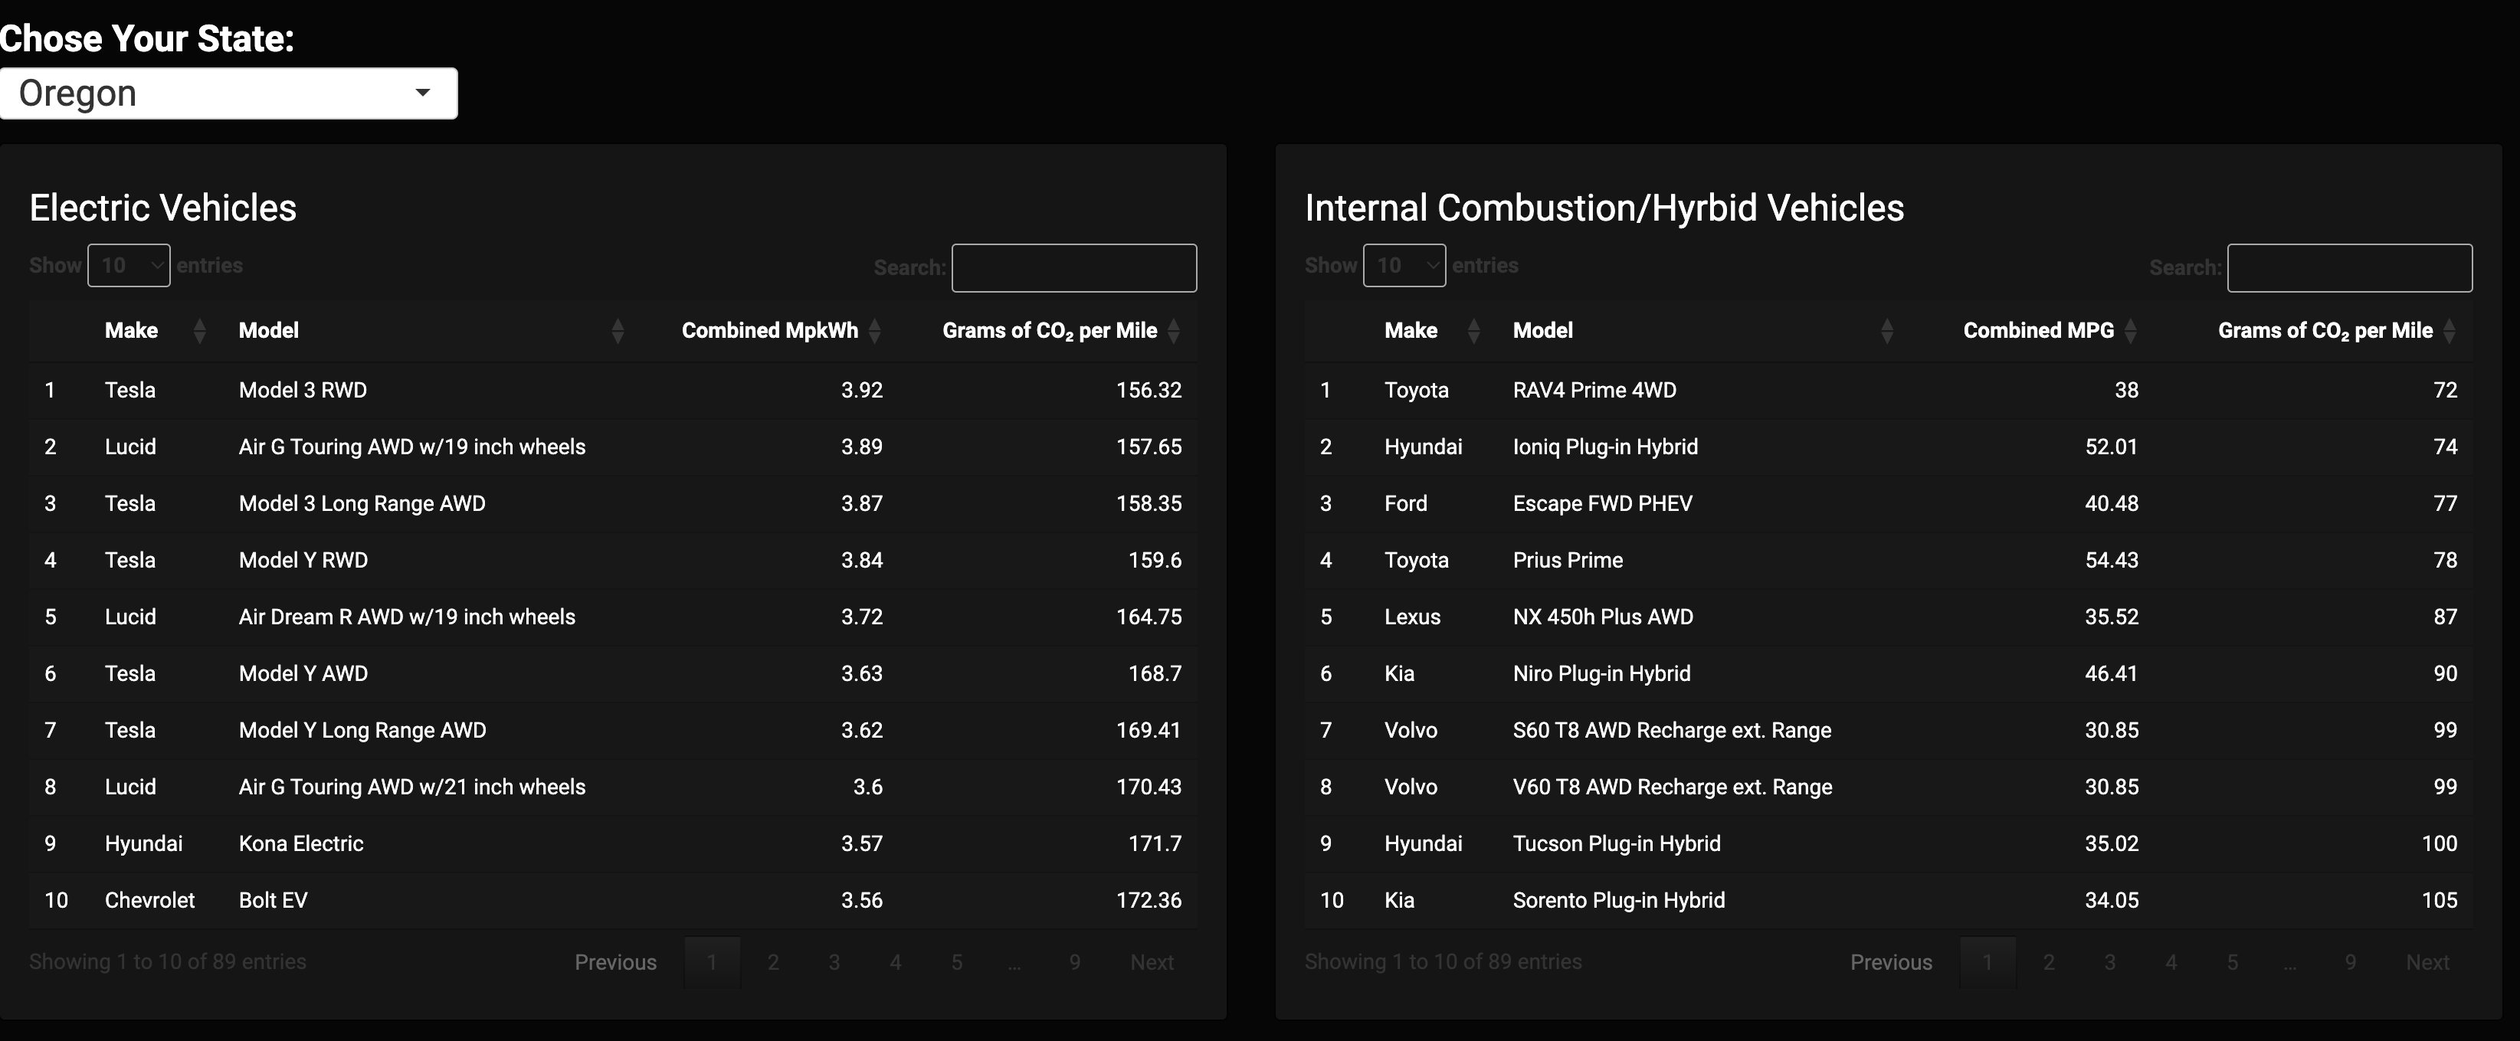
Figure 1
In Alaska, where fossil fuels dominate electricity generation, the disadvantages were even more pronounced: The leading EV (Tesla Model 3 RWD) emitted nearly 23 times more CO₂ per mile than the most efficient vehicle (Toyota RAV4 Prime 4WD) as we can see in figure two below.
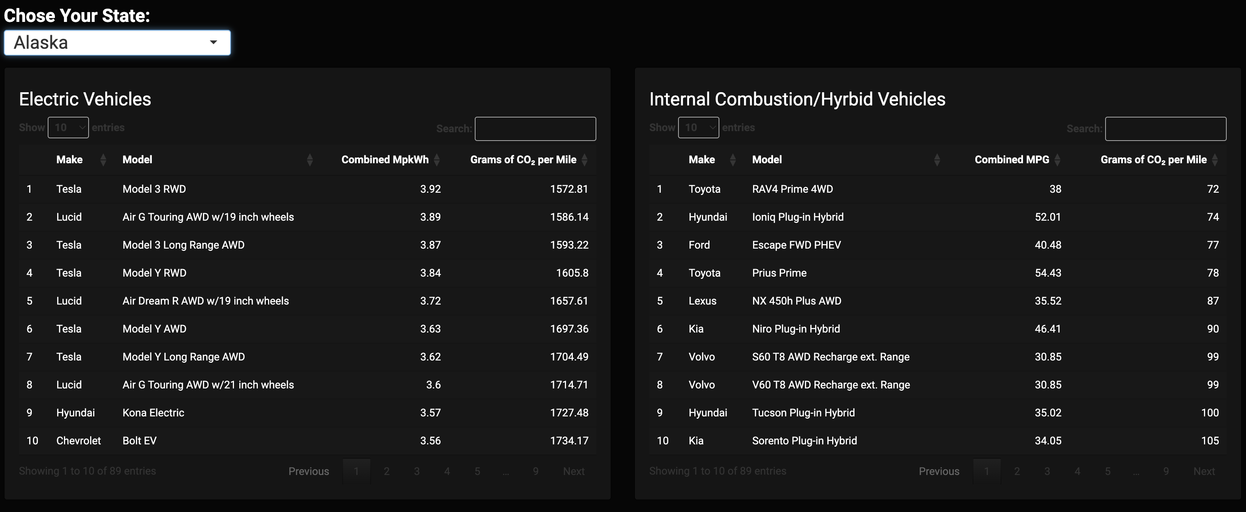
Figure 2
Eight states, 2 per region, emerged as relatively EV-friendly based on electricity emissions data: Oregon and Washington from the West; South Carolina and Alabama from the South; New Hampshire and Connecticut from the North; and South Dakota and Iowa from the Mid-West as seen in figure 3. Still in these states, EVs did not supass ICE/Hyrbid Vehicles in emissions performance.
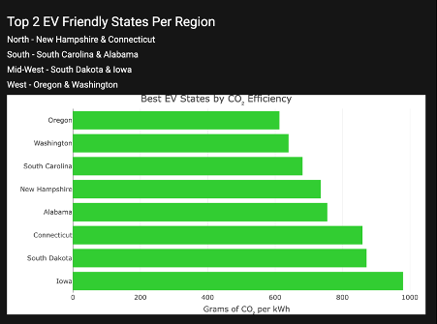
Figure 3
The results are supported by an interactive dashboard build using R and Shiny. Users can select any U.S. state to veiw a side-by-side comparison of grams of CO₂ per mile for EVs and ICE/Hybrid Vehicles. Dynamic data tables display region specific emission and generation values, allowing users to identify top-performing states in their region. Users can also identify top-performing vehicles in carbon emission, or even see how their current vehicle performs in their state.
Additionally, a choropleth map visualizes the total grams of CO₂ emitted from electricity production by state, illustrating which regions and states have cleaner elelctricity grids. As seen in figure 4, states with higher emissions like Texas and California are shaded in a darker shade of orange, representing a higher concentration of CO₂. This visual reinforces the influence of grid compostion on EV Emission.

Figure 4
The data challenged the prevailing narrative around EVs as universally low-emission vehicles. Although EVs offer substantial reduction in operating convienece and routine maintenance, their overall environmental benefit is highly dependant on how clean a state can produce energy. In regions wehre coal and natural gas remain dominant energy sources, EVs produce more CO₂ per mile at a much higher factor than efficient ICE or hybrid vehicles.
This finding underscores the need for a dual-focused approach to decarbonization: promoting EV adoption must be matched by efforts to clean the electrical grid. The results also support the argument that policy incentives should consider regional emissions data. A uniform national policy may overlook significant differences in environmental outcomes based on where an EV is charged. This study demonstrates the importance of contextualizing EV performance within the broader energy ecosystem, rather than evaluating vehicles in isolation.

VI. Discussion
The results of this study demonstrate that the carbon footprint of electric vehicles (EVs) varies significantly depending on the carbon intensity of the electricity grid in each state. Contrary to the widespread perception that EVs are universally cleaner than internal combustion engine (ICE) or hybrid vehicles, the analysis revealed that even the most efficient EVs emit more CO₂ per mile than their ICE counterparts in every U.S. state when accounting for emissions from power generation. This outcome underscores the importance of evaluating vehicle emissions not only by technology type, but also by regional electricity sourcing. These findings highlight that achieving meaningful environmental benefits through EV adoption is not solely a matter of promoting electric vehicles, but rather requires a holistic approach that includes decarbonizing the electrical grid. Without significant improvements in energy production methods, the potential CO₂ reductions from EVs will remain limited or even negative in some regions.
These results are consistent with prior studies that emphasize regional disparities in electricity emissions and their influence on EV sustainability. For instance, Singh et al. (2024) introduced the concept of a critical emissions factor (CEF), above which EVs become less efficient than hybrids. This aligns with the present study’s state-level analysis, which shows EVs failing to meet that CEF threshold in all cases. Similarly, research by Tamayao et al. (2015) and Qin et al. (2022) confirms that cleaner energy grids are essential for maximizing the environmental advantage of EVs. In contrast to some generalized studies that assume nationwide average emissions for EV performance (e.g., Clinton & Steinberg, 2019), this study provides a more granular view, revealing the limitations of national-scale analyses that ignore state-by-state variability. The use of grams of CO₂ per mile as a standardized metric across vehicle types enhances comparability has addresses gaps noted in the literature around unclear or inconsistent emissions reporting.
The original hypothesis posited that EVs offer lower CO₂ emissions per mile than ICE vehicles, but that the degree of advantage depends on the electricity generation profile of each state. The results, however, refute this hypothesis. While it remains true that grid conditions impact EV emissions, the data reveal that in no state did an EV outperform its ICE or hybrid counterpart in terms of CO₂ emissions per mile for the year 2022. Therefore, the findings not only confirm the significance of regional electricity differences but also challenge the broader assumption of EVs’ environmental superiority.
This study focuses exclusively on carbon dioxide emissions from electricity generation and vehicle operation. It does not account for upstream factors such as battery manufacturing, vehicle production, or end-of-life recycling, which are relevant to full life cycle assessments (LCAs). Additionally, the analysis uses 2022 emissions data and assumes uniform charging behavior, while real-world variations—such as time-of-day charging or grid decarbonization trends—may influence results.
Another limitation is the reliance on the combined efficiency ratings of EVs and ICE vehicles from EPA datasets. In practice, individual driving habits, terrain, and weather conditions may affect these ratings. Finally, the transition from a PostgreSQL database to CSV files for deployment introduced minor inconsistencies that required manual variable reconciliation, which may have limited scalability and automation.
Future research could incorporate marginal emissions factors, time-sensitive charging patterns, and projected grid decarbonization scenarios to create a more dynamic emissions model. Expanding the framework to include full life cycle emissions would also provide a more comprehensive view of vehicle sustainability.

VII. Conclusion
This study investigated the carbon dioxide (CO₂) emissions associated with electric vehicles (EVs) across all 50 U.S. states, using 2022 state-level electricity generation data. By calculating grams of CO₂ per mile and comparing the results to those of the most efficient internal combustion engine (ICE) and hybrid vehicles, the research revealed a consistent pattern: in no state did EVs outperform ICE/hybrid vehicles in terms of emissions per mile. Even in states with relatively clean energy grids—such as Oregon and Washington—EVs still emitted more CO₂ than the most efficient gasoline-powered alternatives. These findings challenge common assumptions about the environmental superiority of EVs and underscore the role of regional power generation in shaping actual emissions outcomes.
The implications of this research extend to both policy and consumer behavior. First, it highlights the urgent need to decarbonize state-level power grids if EVs are to achieve their full environmental potential. Without significant improvements in how electricity is produced, EVs may fail to deliver the emissions reductions often attributed to them in public discourse and policymaking. Second, these results suggest that incentives for EV adoption—such as tax credits and rebates—should be more strategically targeted. Instead of uniformly applying incentives nationwide, policies could consider regional electricity profiles to more accurately reflect the environmental return on investment. Additionally, expanding efforts to improve fuel efficiency in ICE and hybrid vehicles should remain a priority, particularly in regions where grid emissions remain high.
Finally, this study provides a foundation for future research and public tools that allow consumers to make better-informed decisions about vehicle purchases based on their local energy context. By offering a transparent, per-mile CO₂ comparison grounded in state-specific data, this work aims to contribute to a more nuanced and regionally aware conversation about sustainable transportation.

VIII. Future Directions
Future studies should incorporate marginal emissions factors and time-of-day charging patterns to better reflect real-world EV emissions. Expanding the analysis to include full life cycle emissions—such as battery production and disposal—would offer a more comprehensive sustainability assessment. Additionally, incorporating projected grid decarbonization scenarios could help forecast how EV emissions may change over time and guide long-term policy planning.

List of References
Ghosh, T., Ingwersen, W. W., Jamieson, M., Hawkins, T. R., Cashman, S., Hottle, T.,
Carpenter, A., & Richa, K. (2023). Derivation and assessment of regional electricity generation emission factors in the USA. The International Journal of Life Cycle Assessment, 28(2), 156-171. https://doi.org/10.1007/s11367-022-02113-1

Qin, X., Tong, D., Liu, F., Wu, R., Zheng, B., Zheng, Y., et al. (2022). Global and regional
drivers of power plant CO₂ emissions over the last three decades revealed from unit-based database. Earth's Future, 10, e2022EF002657. https://doi.org/10.1029/2022EF002657

Tamayao, M.-A. M., Michalek, J. J., Hendrickson, C., & Azevedo, I. M. L. (2015). Regional
Variability and Uncertainty of Electric Vehicle Life Cycle CO~~2~~ Emissions across the United States. Environmental Science & Technology, 49(14), 8844–8855. https://doi-org.proxy.ulib.uits.iu.edu/10.1021/acs.est.5b00815

Singh, M., Yuksel, T., Michalek, J. J., & Azevedo, I. M. L. (2024). Ensuring greenhouse gas
reductions from electric vehicles compared to hybrid gasoline vehicles requires a cleaner U.S. electricity grid. Scientific Reports, 13(1), 1–11. https://doi-org.proxy.ulib.uits.iu.edu/10.1038/s41598-024-51697-1

Ansari, A., Abediasl, H., & Shahbakhti, M. (2024). Ambient Temperature Effects on Energy
Consumption and CO 2 Emissions of a Plug-in Hybrid Electric Vehicle. Energies (19961073), 17(14), 3566. https://doi-org.proxy.ulib.uits.iu.edu/10.3390/en17143566

D. R. Peters, J. L. Schnell, P. L. Kinney, V. Naik, & D. E. Horton. (2020). Public Health and
Climate Benefits and Trade‐Offs of U.S. Vehicle Electrification. GeoHealth, 4(10). https://doi-org.proxy.ulib.uits.iu.edu/10.1029/2020GH000275

Prival, M. J. (2023). The Carbon Footprint of Electric Vehicles in the United States. Low
Carbon Economy ; Volume 14, Issue 02, Page 17-26 ; ISSN 2158-7000 2158-7019. https://doi-org.proxy.ulib.uits.iu.edu/10.4236/lce.2023.142002

Maertz, A., Ploetz, P., & Jochem, P. (2021). Global perspective on CO2 emissions of electric
vehicles. ENVIRONMENTAL RESEARCH LETTERS, 16(5), 054043. https://doi-org.proxy.ulib.uits.iu.edu/10.1088/1748-9326/abf8e1

McLaren, J., Miller, J., O’Shaughnessy, E., Wood, E., & Shapiro, E. (2016). Emissions
associated with electric vehicle charging: Impact of electricity generation mix, charging infrastructure availability, and vehicle type. National Renewable Energy Laboratory (NREL). Technical Report NREL/TP-6A20-64852. Retrieved from https://www.nrel.gov/publications

Isaac, A. J., Jenefa, A., Samuel, R. J. R., Raj, P. J. R., Pratheesh Raj P, L., & Raghul Kanna,
M. (2024). Ecodrive-Deep Learning Models For Accurate Prediction of Vehicle Co2 Emissions. 2024 3rd International Conference on Applied Artificial Intelligence and Computing (ICAAIC), Applied Artificial Intelligence and Computing (ICAAIC), 2024 3rd International Conference On, 689–694. https://doi-org.proxy.ulib.uits.iu.edu/10.1109/ICAAIC60222.2024.10575505

Xiao, Y., Lin, X., Hu, H., Zhang, F., Chen, Z., Tang, J., Gao, Z., & Zhou, M. (2024). System
Dynamics Modeling and Analysis of the Impact of Regional Carbon Emissions by Electric Vehicles Integration. 2024 6th International Conference on Energy Systems and Electrical Power (ICESEP), Energy Systems and Electrical Power (ICESEP), 2024 6th International Conference On, 1618–1624. https://doi-org.proxy.ulib.uits.iu.edu/10.1109/ICESEP62218.2024.1065207

Zaino, R., Ahmed, V., Alhammadi, A. M., & Alghoush, M. (2024). Electric Vehicle
Adoption: A Comprehensive Systematic Review of Technological, Environmental, Organizational and Policy Impacts. World Electric Vehicle Journal, 15(8), 375. https://doi.org/10.3390/wevj15080375

Jenn, A., Springel, K., & Gopal, A. R. (2018). Effectiveness of electric vehicle incentives in
the United States. Energy Policy, 119, 349-356. https://doi.org/10.1016/j.enpol.2018.04.065

Clinton, B. C., & Steinberg, D. C. (2019). Providing the Spark: Impact of financial incentives
on battery electric vehicle adoption. Journal of Environmental Economics and Management, 98. https://doi-org.proxy.ulib.uits.iu.edu/10.1016/j.jeem.2019.102255

United States Environmental Protection Agency (EPA). (n.d.). Electric vehicle myths. U.S.
Environmental Protection Agency. Retrieved February 5, 2025, from https://www.epa.gov/greenvehicles/electric-vehicle-myths

Min Seong Kim, M. (2023). The Electric Vehicles Dilemma: The Inflation Reduction Act,
International Trade Law, and U.S.-Korea Economic Diplomacy. New York University Journal of Legislation & Public Policy, 25(3), 875–923.

McDonnell, T. E., Gabur, A., & Keynton, R. (2023). “I’m Saving Fuel to Buy More Guns”:
The Electric Vehicle as Cultural Object and Climate Policy Solution^^1^^. Sociological Forum, 38(4), 1408–1422. https://doi-org.proxy.ulib.uits.iu.edu/10.1111/socf.12953

Link to the References
My Google Drive

